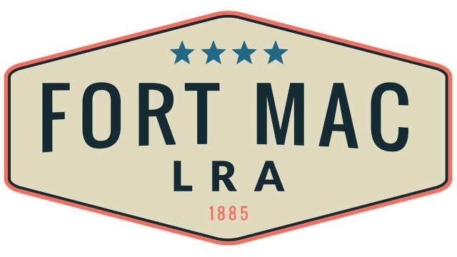

McPherson Implementing Local Redevelopment Authority
The Fort Mac LRA
Board of Directors meeting scheduled for Thursday,
June 16, 2022@ 1PM
here at
Fort Mac LRA
1794 Walker Avenue SW
Atlanta, GA 30310
Has been CANCELLED!!!

