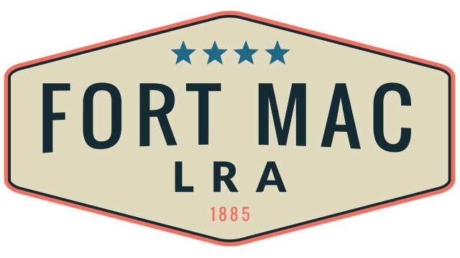
McPherson Implementing Local Redevelopment Authority

The Fort Mac LRA Board of Directors
will meet Thursday, July 21, 2022
at 1pm-3:30pm
at the office of Fort Mac LRA
1794 Walker Ave., SW
Atlanta, GA 30310

