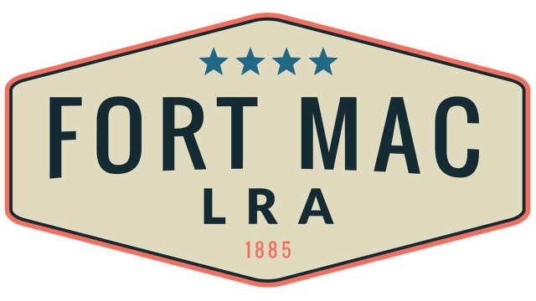
McPherson Implementing Local Redevelopment Authority

Fort Mac LRA
Finance Committee will meet
Thursday, July 21, 2022 @12:30pm!!!
at the office of Fort Mac LRA
1794 Walker Ave., SW
Atlanta, GA 30310

