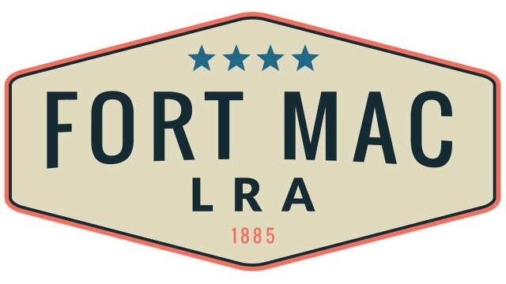
McPherson Implementing Local Redevelopment Authority

The Fort Mac LRA Board of Directors

will meet Thursday, August 18, 2022

at 1pm-3:30pm

at the office of Fort Mac LRA

1794 Walker Ave., SW

Atlanta, GA 30310

