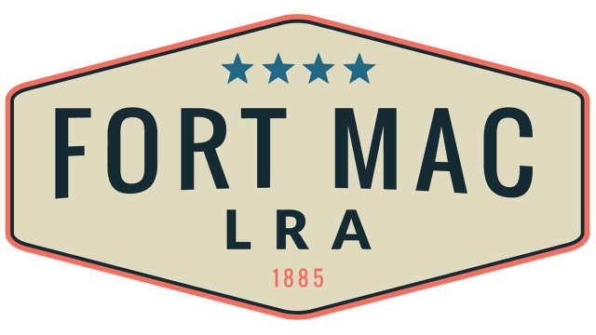
McPherson Implementing Local Redevelopment Authority

Fort Mac LRA

Finance Committee will meet

Thursday, August 18, 2022 @12:30pm!!!

at the office of Fort Mac LRA

1794 Walker Ave., SW

Atlanta, GA 30310

