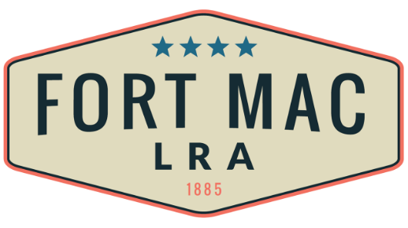
McPherson Implementing Local Redevelopment Authority

The Fort Mac LRA
Public Art Advisory Committee (PAAC)
Special Called Meeting
will be held
On Thursday, August 18, 2022
5:30 pm-7:30pm
At the office of Fort Mac LRA
1794 Walker Ave., SW
Atlanta, GA 30310

