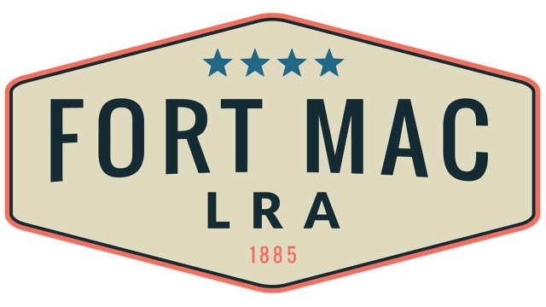
McPherson Implementing Local Redevelopment Authority
The Fort Mac LRA
Finance Committee
Meeting scheduled at 12:30pm
Thursday, September 15, 2022
At the office of Fort Mac LRA
1794 Walker Ave., SW
Atlanta, GA 30310
Has Been CANCELLED!!!

