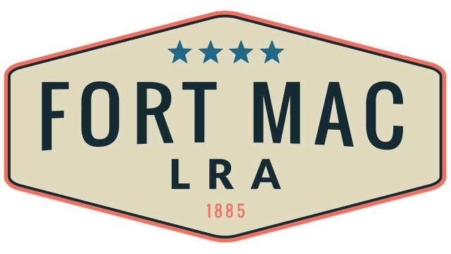
McPherson Implementing Local Redevelopment Authority

Fort Mac LRA
Finance Committee will meet
Thursday, October 20, 2022
12:30pm-1:00pm
at the office of Fort Mac LRA
1794 Walker Ave., SW
Atlanta, GA 30310

