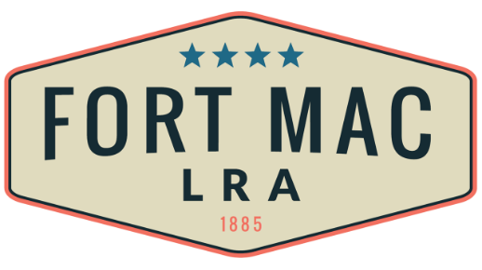
McPherson Implementing Local Redevelopment Authority

The Fort Mac LRA
Community Engagement Subcommittee,
will meet
On Wednesday, October 26, 2022
5:30 pm-7:30pm
At the office of Fort Mac LRA
1794 Walker Ave., SW
Atlanta, GA 30310

