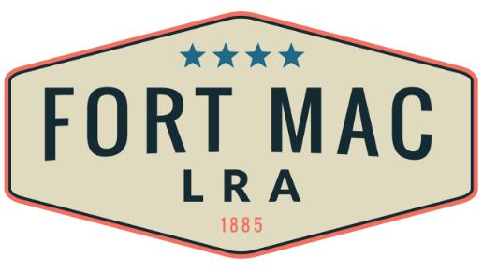

McPherson Implementing Local Redevelopment Authority
Finance Committee Meeting
March 1, 2021

A meeting of the Finance Committee of the McPherson Implementing Local Redevelopment Authority (Fort Mac LRA) was held on Monday, March 1, 2021 via Zoom.

Committee Members:
Ernestine Garey, Chairwoman
Sondra Rhoades-Johnson
Carmen Chubb
Aaron Watson

Other Board Members:
N/A

Staff, Legal Counsel and Others:
David Burt, Executive Director Fort Mac LRA
Sandra Tennyson, Fort Mac LRA
Pete Hayley, Fort Mac LRA
CeCe Ross, Fort Mac LRA
Robert Mosby, Fort Mac LRA
Joyce Allen, Fort Mac LRA
Tracey Upshaw, Fort Mac LRA
Peter Andrews, Greenberg Traurig
Mark Hayes, Mark Hayes Consulting, LLC

Guests:
No one signed in

Announcements and Welcome:
Chair Ernestine Garey, called the meeting to order at approximately 4:06 P.M. and announced a quorum.

Approval of Agenda:
Chairman Garey called for approval of the Agenda. A motion to approve was properly made and seconded. Approval was unanimous.

Approval of the Minutes:
Chairman Garey called for approval of the December 11, 2020 minutes. A motion to approve was properly made and seconded. Approval was unanimous.

Public Comment:
No one signed in.

2021-2022 DRAFT Budget:
Robert Mosby, Controller, Fort Mac LRA, presented a walk-through of the FMLRA 2021-2022 Draft Budget as of February 23, 2021, detailing information on line items under the following headings: Operating Budget, Staff, General Administration, Consulting & Legal, Master Development, Site Planning & Analysis, Caretaker and Other Expenses. He concluded with an explanation of the Contingency item which indicated a balanced budget.

Mr. Mosby entertained questions from the Committee and as a result, will follow-up with minor revisions to the draft of the 2021-2022 budget, a 2022 budget projection based on the 2021 budget and preparation of an RFP to shop 2021 audit entities based on performance and cost.

Chairman’s Announcements:
Chairman Garey requested that the Finance Committee meet every month 10 days in advance of the Fort Mac LRA Board of Directors meetings. Therefore, the next meeting of the Finance Committee will be held on Monday, April 5, 2021 at 4:00 P.M.. Committee members concurred.

Next Meetings Date and Time:
Development Committee March 2, 2021
Finance Committee April 5, 2021
Board Meeting March 18, 2021
Community Engagement Subcommittee March 24, 2021

Adjournment:
The Chair asked for a motion to adjourn. A motion was properly made and seconded. Approval was unanimous.

The meeting was adjourned at approximately 4:55 P.M.

(signatures follow)

