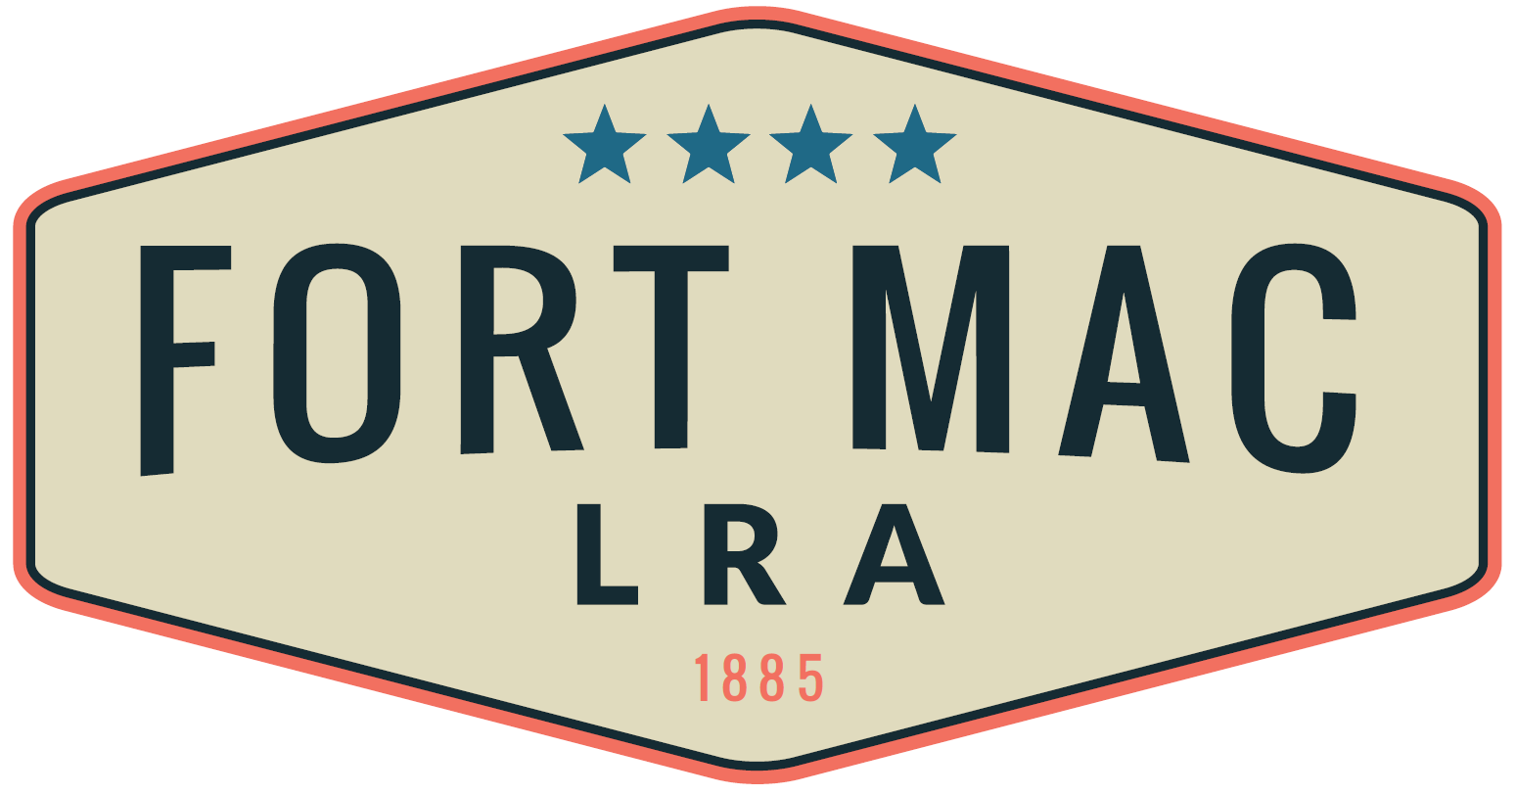
McPherson Implementing Local Redevelopment Authority

April 19, 2024
REQUEST FOR PROPOSALS
GROUNDS KEEPING SERVICES

ATTENTION RESPONDENTS

You are hereby invited to submit a quote to the McPherson Implementing Local Redevelopment Authority (hereafter referred to as “Fort Mac LRA”) to provide Grounds Keeping Services. A successful Respondent (or Respondent team) will be selected by Fort Mac LRA based on the Respondent’s ability to provide the services described in the Scope of Services (as summarized below), competitive pricing for such services, and other factors listed herein.

Potential Respondents are asked to direct all questions concerning this Request for PROPOSALS or “RFP” process to CeCe Ross, Asset and Property Manager, via email at cross@fortmaclra.com.

Send your complete response to this RFP to CeCe Ross at cross@fortmaclra.com, no later than 2:00 pm E.D.T. on May 20, 2024. Absolutely no responses will be accepted after 2:00 pm E.D. T. on May 20, 2024. Please limit your responses to 7-10 pages.

Fort Mac LRA reserves the right, in its sole discretion, to reject any submittal it considers to be non-responsive. Fort Mac LRA reserves the right to cancel any and all solicitations and to accept or reject, in whole or in part, any and all submittals when it is in the best interest of Fort Mac LRA. Should Fort Mac LRA fail to reach agreement with any Respondent(s) initially selected, Fort Mac LRA reserves the right to commence negotiations with the next highest ranked Respondent or team of Respondents. Fort Mac LRA shall select the Respondent (or Respondent team) it considers best qualified and as providing the best value to Fort Mac LRA in its sole discretion. Fort Mac LRA may select a Respondent without an interview or may choose to interview all or a limited number of Respondents prior to selecting the successful Respondent (or Respondent team). The cost of preparing responses will be the responsibility of each Respondent and will not be reimbursed.

REQUEST FOR PROPOSALS

This Request for PROPOSALS for Grounds Keeping Services is hereby issued by Fort Mac LRA in accordance with applicable law. Fort Mac LRA is issuing this Request for PROPOSALS for Grounds Keeping Services provider to maintain a clean, manicured site for current users, on site marketing presentations to future developers, and other interested parties. Property holdings are to be maintained at a level commensurate with other similar commercial sites within the metro Atlanta area. Fort Mac LRA is seeking a qualified Respondent (or Respondent team) that can provide the labor, supplies and equipment to provide Grounds Keeping services of existing groundcover (Fort Mac LRA parcel), see Exhibit A.

Scope of Services

Your quote should include a detailed scope of services and corresponding project plan and phasing recommendations that addresses the items below and in the entirety of the RFP.

- Provide labor, supplies, and equipment to maintain a year-round seasonal ground keeping schedule for all greenspace within Fort Mac LRA’s acres as shown in Exhibit A of this RFP. This schedule should include a staffing plan and equipment allocations for this project.
- Maintenance shall include lawns, shrubbery and other vegetation on the site as defined in Exhibit A attached.
- Contractor shall cut property twice a month at the level of 2-4 inches. Maintenance cycle should be achieved within one week, pending weather conditions. Fort Mac LRA may decrease or increase the frequency of the landscape services depending on the activities planned on the site. As redevelopment occurs, we anticipate scaling down on the volume of services.
- Services should proceed immediately after any weather-related work interruption.
- In addition to the area described in Exhibit A, maintenance of property in the public pedestrian greenspace (sidewalks) on the Fort Mac LRA/Lee Street boundary and the Fort Mac LRA/Campbellton Road (as requested) shall be provided.
- Plans detailing the safety precautions, standards and apparatus must be included in your description of services to be provided as part of your response to this quote.
- This quote shall exclude tree care services but shall include removal of all debris (such as leaves, twigs, small branches, etc.) and broken limbs to a designated site within the overall facility.
- Contractor shall remove leaves and debris during fall and winter months weekly from all roadways and storm drains. Collected leaves shall be removed daily.
- Contractor shall remove vines, bushes, tree limbs from facility surfaces.
- Contractor shall remove grass, weeds, tree limbs, and all other vegetation at pavement level or within fence lines of both the boundary fence and the Base fence for the entire perimeter.

CONTRACT TERM

Respondents are encouraged to submit PROPOSALS for all landscape services for all areas located within the areas denoted on Exhibit A (referred to as the “Fort Mac LRA parcel”) for a one year term with an option of two, one year annual renewals or extensions. Contract commencement date shall be the date of the issuance of the Notice to Proceed (NTP).

INFORMATION AND INSTRUCTIONS TO RESPONDENTS
A successful Respondent (or Respondent team) will be selected by Fort Mac LRA based on the process as herein described below.

SCHEDULE

It is anticipated that the solicitation and selection process shall be conducted in accordance with the following schedule provided, however, Fort Mac LRA reserves the right to modify this schedule in its sole discretion.

RFP Invitation: April 19, 2024
Questions Due: May 3, 2024 (5:00 pm)
Answers Published: May 7, 2024 (Close of Business)
PROPOSALS Due: May 20, 2024 (2:00 pm)
Interviews (Optional) May 22, 2024
Selection May 24, 2024

QUOTE SUBMITTAL

Send your complete response to this RFP to cross@fortmaclra.com. Your response must be received, no later than 2:00 pm E.D.T on May 20, 2024. Absolutely no responses will be accepted after 2:00 pm E.D.T. Any submittal received after the time stipulated will not be considered and will be rejected and returned to the Respondent. Submittals must be responsive to all requirements outlined herein.

SUBMISSION REQUIREMENTS

The following are minimum RFP submission requirements. Failure to meet any one of these criteria may result in rejection of a submittal. Each section of your qualifications should be clearly labeled and meet the following submission requirements.

- Introductory Cover letter which introduces your company and the personnel that will work on this project. Please identify the lead person for your company or team.
- Description of your Respondent (or Respondent team) including history, a list of Grounds Keeping projects managed, and results. Include projects that are similar to this project.
- Identify team lead and other key personnel that would be assigned to this project and their resumes and credentials.
- Describe your general approach to the engagement, and if applicable, the application of your established Grounds Keeping methodology to this project.
- Provide Insurance Documentation (or prospective documentation) as follows:
- Certificate of Insurance for General Liability in the amount of $2 million.
- Professional Liability insurance in the amount of $1 million with a $1 million aggregate.
- Name of Workers Compensation Insurance Provider with statutory limits.

DBE Participation: Fort Mac LRA encourages all interested Respondents to promote opportunities for diverse businesses, including Female Business Enterprises (“FBE”), Minority Business Enterprises (“MBE”) and Small Business Enterprises (“SBEs” and together with FBEs and MBEs, “DBEs”) to compete for business as consultants, sub-consultants and/or suppliers. Goals are based on the Scope of Work and general availability of Respondent (or Respondent team) with the requisite experience and capacity to perform the work. Consultants are encouraged to involve DBEs in all aspects of the work. All Respondents shall include specific information regarding DBE participation, if any.

SELECTION PROCESS AND NEGOTIATION

The most responsive Respondent (or Respondent team) will be identified, and Fort Mac LRA will proceed to the negotiation of an agreement process. Selection criteria for the most responsive Respondent are listed below in the section marked “Selection Criteria”. Fort Mac LRA and the successful Respondent would negotiate an agreement promptly following the selection. If a mutually satisfactory contract cannot be reached with the selected Respondent, Fort Mac LRA may enter into negotiations with the second-place Respondent as determined under the selection criteria.

Pricing should be in the form of a Fixed Fee with a monthly fee per service. The selection will be based on the qualifications of the Respondent as presented in the information submitted. Evaluation will be weighted heavily on price and experience; however, all other evaluation criteria will be considered as well. Fort Mac LRA reserves the right to call references provided in the submittal and to require phone or personal interviews with Respondent (or Respondent team) requiring additional evaluation. The following criteria will be used for evaluation.

- Pricing for services defined in the RFP must be for a Fixed Fee to include all equipment and supplies.
- Quality of the non-priced submittal components of the response.
- Related experience of the Respondent (or Respondent team) with similar projects.
- Inclusion of DBE participation goals. Utilization of local business (Greater Atlanta Area) with special emphasis on the businesses for the communities located within a three-mile radius from Fort Mac LRA’s outer perimeter.

Selection criteria that will be used to select the successful Respondent are set forth below:

Criteria | Points
Pricing Approach | 30
Lead Consultant Experience and Respondent (or Respondent team) Experience with similar Projects | 30
Methodology and Timeline | 10
DBE Participation | 30
Total | 100

Fort Mac LRA is an equal opportunity employer and will select a Respondent (or Respondent team) without regard to age, disability, religion, creed or belief, political affiliation, race, sex or ethnicity.

References and Additional Information

Include names, telephone numbers, email addresses, and street addresses for all references. Provide three (3) references from projects that are comparable to this engagement. Include any other information that you feel is pertinent but not specifically asked for herein.

CONTACT PERSONS

Questions concerning any aspect of this project, including the submittal process, should be directed to CeCe Ross, Asset and Property Manager. Suggestions and questions regarding the RFP and the proposed Scope of Services should be made in writing via e-mail to cross@fortmaclra.com no later than May 3, 2024, by 5:00 pm E.D.T. Answers to those questions will be shared with all parties who have expressed interest by the close of business May 7, 2024.

FORT MAC LRA POLICY ON COMMUNICATIONS AND CONTACT

Respondents are required to conduct the preparation of their applications with professional integrity and free of lobbying activities. Respondents and their respective agents and consultants are not permitted to contact or communicate with, directly or indirectly, any member of the Fort Mac LRA Board regarding the subject matter of this RFP after final questions have been answered on May 7, 2024, except as specifically permitted herein or approved in advance by Fort Mac LRA. Any verified allegation that a Respondent or team member, or an agent or consultant of the foregoing, has made such contact or attempted to influence the evaluation, ranking, and/or selection of Respondents is cause for Fort Mac LRA to disqualify the Respondent and its team member from further consideration.

OPEN GOVERNMENT LAWS

All Respondents should obtain and thoroughly familiarize themselves with the Georgia Open Records Act (O.C.G.A. S 50-18-70, et seq.) and Georgia Open Meetings (O.C.G.A. S 50-14-1, et seq.) (Collectively, the "Open Government Laws") applicable to the issue of confidentiality and public information. Fort Mac LRA will not advise a Respondent(s) as to the nature or content of documents entitled to protection from disclosure under the Open Government Laws, as to the interpretation of such laws, or as to definition of "proprietary." Each Respondent(s) shall be solely responsible for all determinations made by it under applicable laws. Each proposer/Respondent(s) is advised to contact its own legal counsel concerning the effect of applicable Open Government Laws to that Respondent(s)'s own circumstances.

EXHIBIT A – Fort Mac LRA Parcel
