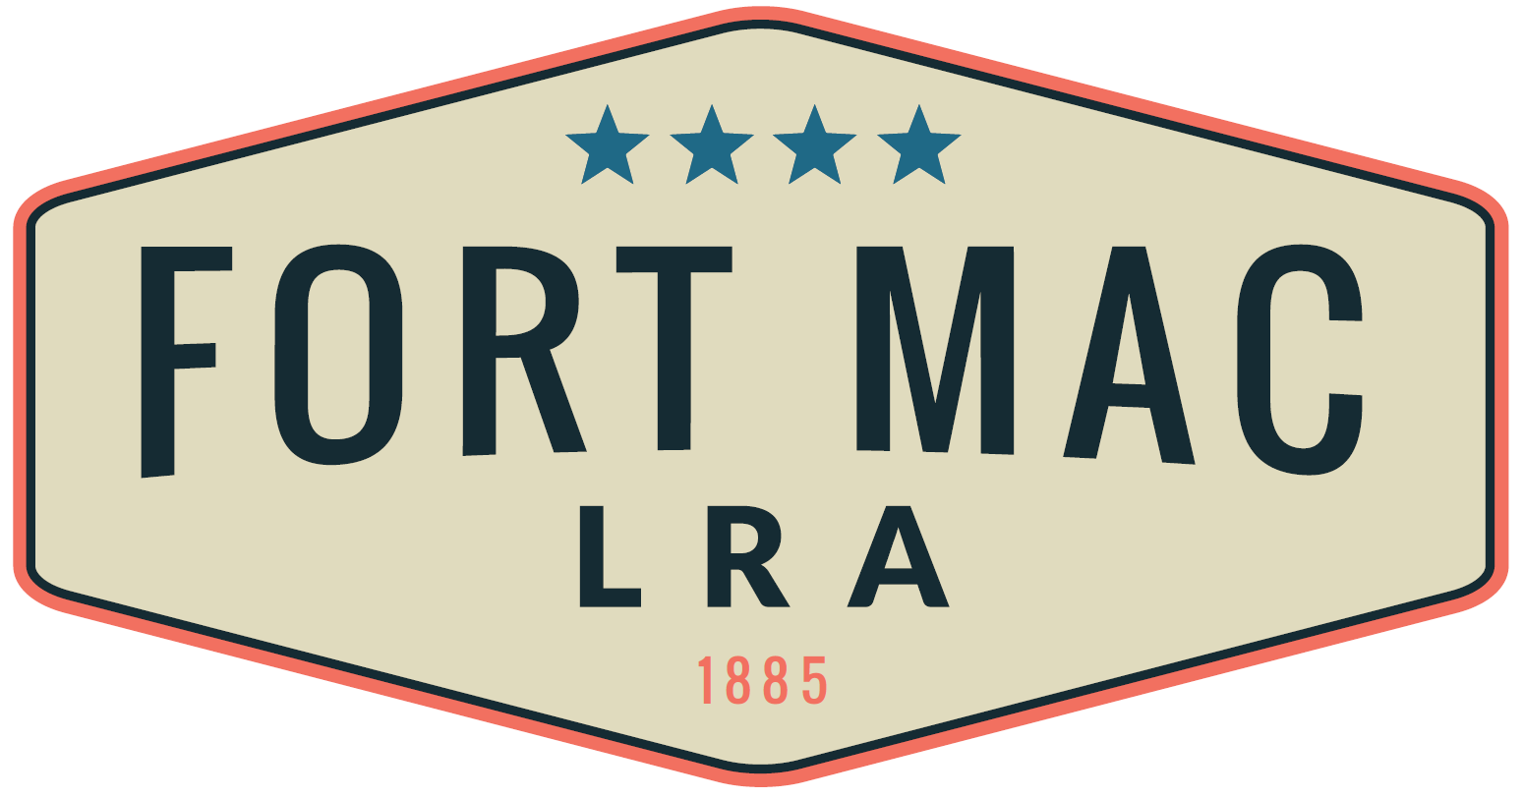
MCPHERSON IMPLEMENTING LOCAL REDEVELOPMENT AUTHORITY
April 19, 2024
REQUEST FOR PROPOSALS
OPERATIONS AND MAINTENANCE SERVICES

ATTENTION RESPONDENTS

You are hereby invited to submit a proposal to the McPherson Implementing Local Redevelopment Authority (hereafter referred to as "Fort Mac LRA") to provide Operations and Maintenance Services. A successful Respondent (or Respondent team) will be selected by Fort Mac LRA based on the Respondent’s ability to provide the services described in the Scope of Services (as summarized below), competitive pricing for such services, and other factors herein listed.

Potential Respondents are asked to direct all questions concerning this Request for Proposals or "RFP" process, to CeCe Ross, Asset and Property Manager, via e-mail at cross@fortmaclra.com.

Send your complete response to this RFP to CeCe Ross at cross@fortmaclra.com, no later than 2:00 pm E.D.T on May 20, 2024. Absolutely no responses will be accepted after 2:00 pm E.D.T on May 20, 2024. Please limit your responses to 7-10 pages.

Fort Mac LRA reserves the right, in its sole discretion, to reject any submittal it considers to be non-responsive. Fort Mac LRA reserves the right to cancel any and all solicitations and to accept or reject, in whole or in part, any and all submittals when it is in the best interest of Fort Mac LRA. Should Fort Mac LRA fail to reach agreement with any Respondent(s) initially selected, Fort Mac LRA reserves the right to commence negotiations with the next highest ranked Respondent or team of Respondents. Fort Mac LRA shall select the Respondent (or Respondent team) it considers best qualified and as providing the best value to Fort Mac LRA in its sole discretion. Fort Mac LRA may select a Respondent without an interview or may choose to interview all or a limited number of Respondents prior to selecting the successful Respondent (or Respondent team). The cost of preparing responses will be the responsibility of each Respondent and will not be reimbursed.

REQUEST FOR PROPOSALS

This Request for Proposals for Operations and Maintenance Services is hereby issued by Fort Mac LRA in accordance with applicable law. Fort Mac LRA wants to maintain its facilities. Property holdings are to be maintained at a level commensurate with other similar commercial sites within the metro Atlanta area. Fort Mac LRA is seeking a qualified Respondent that can provide the labor, supplies and equipment to provide operations and maintenance services to Fort Mac LRA's 67 buildings. We anticipate approximately 30 hours per week for these services. The need for these services may be scaled up as our redevelopment project progresses. Additionally, we anticipate another possible twenty hours per month for emergency on call services.

SCOPE OF SERVICES

Your proposal should include a detailed scope of services and corresponding project plan that addresses the items below and in the entirety of this RFP.

I. PRINCIPAL RESPONSIBILITIES
The Operations and Maintenance r Services will be an intricate part of the Fort Mac LRA Real Estate Team and will report directly to the Asset and Property Manager. The Operations and Maintenance Services function is responsible for the oversight and day to day operations for real estate and other assets owned or controlled by Fort Mac LRA. This includes planning and coordinating maintenance and upkeep of “Exhibit A” redevelopment portfolio. Additionally, scheduling and delegating projects and conducting evaluations of activities are also responsibilities.

- Manage building maintenance activities, ensuring that buildings meet government regulations and environment, health, safety and security standards.
- Maintain energy efficiency and cost effectiveness.
- Oversee multi-disciplinary teams including third party contractors. (HVAC, Plumbing, Electrical, Turnkey/Construction, Maintenance and Custodial services).
- Ensure that all services are effectively delivered and facilities needs are met.
- Conduct ongoing performances and evaluations of systems.
- Ability to assist in the procurement process of securing of reliable, knowledgeable and accountable vendors to complete various tasks.
- Contribute towards annual preventable maintenance, facility improvements and cost reduction initiatives.

II. FACILITIES MANAGEMENT

- Ensure fire protection equipment is properly maintained and up-to-date.
- Perform routine maintenance and minor repairs to buildings and facilities including carpentry and painting.
- Coordinate licensed inspections as required.
- Conduct routine, non-licensed inspections of facilities including fire equipment and boilers.
- Coordinate major maintenance and repairs as required to mechanical systems, HVAC systems, boilers, generators and chillers.
- Advise Fort Mac LRA’s Asset and Property Manager of required major repairs or replacements, in a timely manner. Ensure the safety and protection of buildings including ensuring doorways are not blocked and that buildings and facilities are locked when not in use.
- Create efficient and effective reporting of facilities management tasks for assets at Fort Mac LRA, including maintaining records of quarterly maintenance checklists, daily/weekly/monthly routine maintenance, scheduled work and inspections, incoming mail and email, etc.
- Monitor and maintain utility meters and services pertaining to water, gas and electric.
- Monthly reading of meters.
- Negotiate cost effective service contracts and maintenance services.

INFORMATION AND INSTRUCTIONS TO RESPONDENTS

A successful Respondent (or Respondent team) will be selected by Fort Mac LRA based on a process as herein described.

SCHEDULE

It is anticipated that the solicitation and selection process shall be conducted in accordance with the following schedule provided, however, Fort Mac LRA reserves the right to modify this schedule in its sole discretion.

RFP Invitation: April 19, 2024
Questions Due: May 3, 2024
Answers Published: May 7, 2024
Proposals Due: May 20, 2024 – 2:00 pm
Interview (Optional) May 22, 2024
Selection: May 24, 2024

PROPOSAL SUBMITTAL

Send your complete response to this RFP to cross@fortmaclra.com. Your response must be received, no later than 2:00 pm E.D.T on May 20, 2024. Absolutely no responses will be accepted after 2:00 pm E.D.T on May 10, 2024. Any submittal received after the time stipulated will not be considered and will be rejected and returned to the Respondent. Submittals must be responsive to all requirements herein outlined.

SUBMISSION REQUIREMENTS

The following are minimum RFP submission requirements. Failure to meet any one of these criteria may result in rejection of a submittal. Each section of your qualifications should be clearly labeled and meet the following submission requirements.

- Introductory Cover letter which introduces your company and the personnel that will work on this project. Please identify the lead person for your company or team.
- Description of your firm including history, a list of consulting/development projects managed, and results. Include projects that are similar to this project.
- Identify lead person and other key personnel that would be assigned to this project and their resumes and credentials.
- Describe your general approach to the engagement, and if applicable, the application of your established consulting methodology to this project.
- Demonstrate in depth knowledge of a variety of funding and financing alternatives that may be applied to this project.
- Provide Insurance Documentation (or prospective documentation) as follows:
- Certificate of Insurance for General Liability in the amount of $2 million.
- Professional Liability insurance in the amount of $1 million with a $1 million aggregate.
- Name of Workers Compensation Insurance Provider with statutory limits.

DBE Participation: Fort Mac LRA encourages all interested Respondents to promote opportunities for diverse businesses, including Female Business Enterprises (“FBE”), Minority Business Enterprises (“MBE”) and Small Business Enterprises (“SBEs” and together with FBEs and MBEs, “DBEs”) to compete for business as consultants, sub-consultants and/or suppliers. Goals are based on the Scope of Work and general availability of firms with the requisite experience and capacity to perform the work. Consultants are encouraged to involve DBEs in all aspects of the work. All Respondents shall include specific information regarding DBE participation, if any.

SELECTION PROCESS AND NEGOTIATION

Fort Mac LRA may select one or more Respondents for in-person interviews. The most responsive firm or Respondent will be identified, nd Fort Mac LRA will proceed to the interview and the negotiation of an agreement process. Selection criteria for the most responsive Respondent are listed below in the section marked “Selection Criteria”. Fort Mac LRA and the successful Respondent would negotiate an agreement promptly following the selection. If a mutually satisfactory contract cannot be reached with the selected Respondent, Fort Mac LRA may enter into negotiations with the second-place Respondent as determined under the selection criteria.

Selection criteria that will be used to select the successful Respondent are set forth below:

Criteria | Points
Lead Team Experience and Firm Experience with similar projects | 30
Methodology and Timeline | 30
Pricing Approach | 25
DBE Participation | 15
Total | 100

References and Additional Information

Include names, telephone numbers, email addresses, and street addresses for all references. Provide three (3) references from projects that are comparable to this engagement. Include any other information that you feel is pertinent but not specifically asked for herein.

CONTACT PERSONS

Questions concerning any aspect of this project, including the submittal process, should be directed to CeCe Ross, Asset and Property Manager at cross@fortmaclra.com. Suggestions and questions regarding the RFP and the proposed Scope of Services should be made in writing via e-mail to cross@fortmaclra.com not later than May 3, 2024 by 5:00 pm E.D.T. Answers to those questions will be shared with all parties who have expressed interest by close of business May 7, 2024.

FORT MAC LRA POLICY ON COMMUNICATIONS AND CONTACT

Respondents are required to conduct the preparation of their applications with professional integrity and free of lobbying activities. Respondents and their respective agents and consultants are not permitted to contact or communicate with, directly or indirectly, any member of the Fort Mac LRA Board regarding the subject matter of this RFP after the issuance date of this RFP, except as specifically permitted herein or approved in advance by Fort Mac LRA. Any verified allegation that a Respondent or team member, or an agent or consultant of the foregoing, has made such contact or attempted to influence the evaluation, ranking, and/or selection of Respondents is cause for Fort Mac LRA to disqualify the Respondent and its team member from further consideration.

OPEN GOVERNMENT LAWS

All Respondents should obtain and thoroughly familiarize themselves with the Georgia Open Records Act (O.C.G.A. S 50-18-70, et seq.) and Georgia Open Meetings (O.C.G.A. S 50-14-1, et seq.) (Collectively, the "Open Government Laws") applicable to the issue of confidentiality and public information. Fort Mac LRA will not advise a Respondent(s) as to the nature or content of documents entitled to protection from disclosure under the Open Government Laws, as to the interpretation of such laws, or as to definition of "proprietary." Each Respondent(s) shall be solely responsible for all determinations made by it under applicable laws. Each proposer/Respondent(s) is advised to contact its own legal counsel concerning the effect of applicable Open Government Laws to that Respondent(s)'s own circumstances.

Exhibit A

