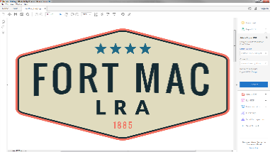
McPherson Implementing Local Redevelopment Authority

June 2026 Special Called Board Meeting
Agenda
June 23, 2026 – 9:00am

- Call to Order Butts
- Introduction of Denmark, Ashby, Matricardi Burt
- Determination of Quorum Matricardi
- Welcome and Announcements Butts
- Approval of Meeting Agenda Butts
- Approval of Meeting Minutes – March 5, 2026 Butts
- Executive Session Butts
  - Legal Matters
  - Real Estate Matters
  - Personnel
- Presentation of 2026/2027 Budget Mosby
- Resolution to Approve MILRA 2026/2027 Budget Garey
- Property Update Burt
- Chairman’s Announcements Butts
- Public Comments Butts
- Adjournment Butts

